DevOps Monitoring Mini Project

Monitoring our Git Hub using Grafana

**Step 1: - Launch a ec2 instance with t2.medium 25 gb storage**

Make sure that we have correct port number opened pass the traffic to/fro internet.

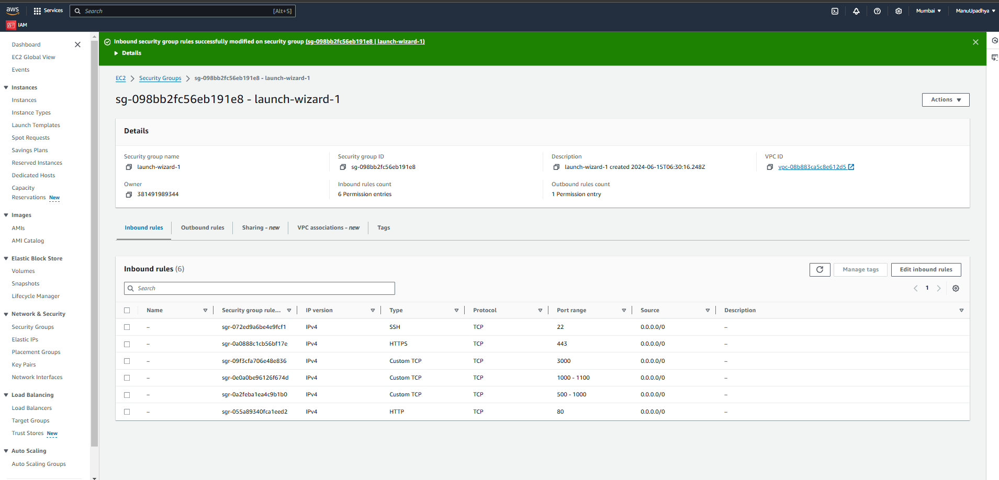  
  
Creation of Ec2 instance steps are not included as it is easy.

Installed EC2 instance.

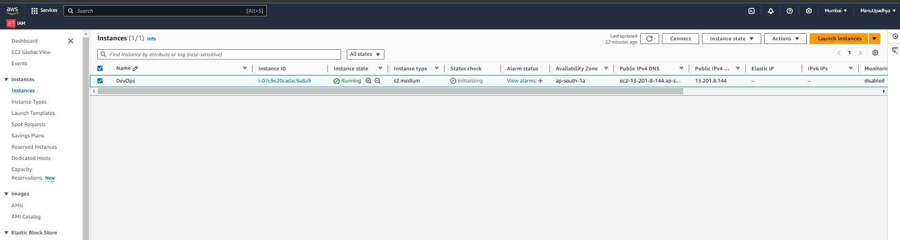

**Step 2: - Install Grafana on top of installed ec2 instance.**

Install Grafana with respect to the O.S we have used in EC2 Instance. In my case I have used yum based operating system.

Use the below commands to install the commands.

**yum install update**

**sudo yum install-y** [**https://dl.grafana.com/enterprise/release/grafana-enterprise-11.3.0-1.x86_64.rpm**](https://dl.grafana.com/enterprise/release/grafana-enterprise-11.3.0-1.x86_64.rpm)

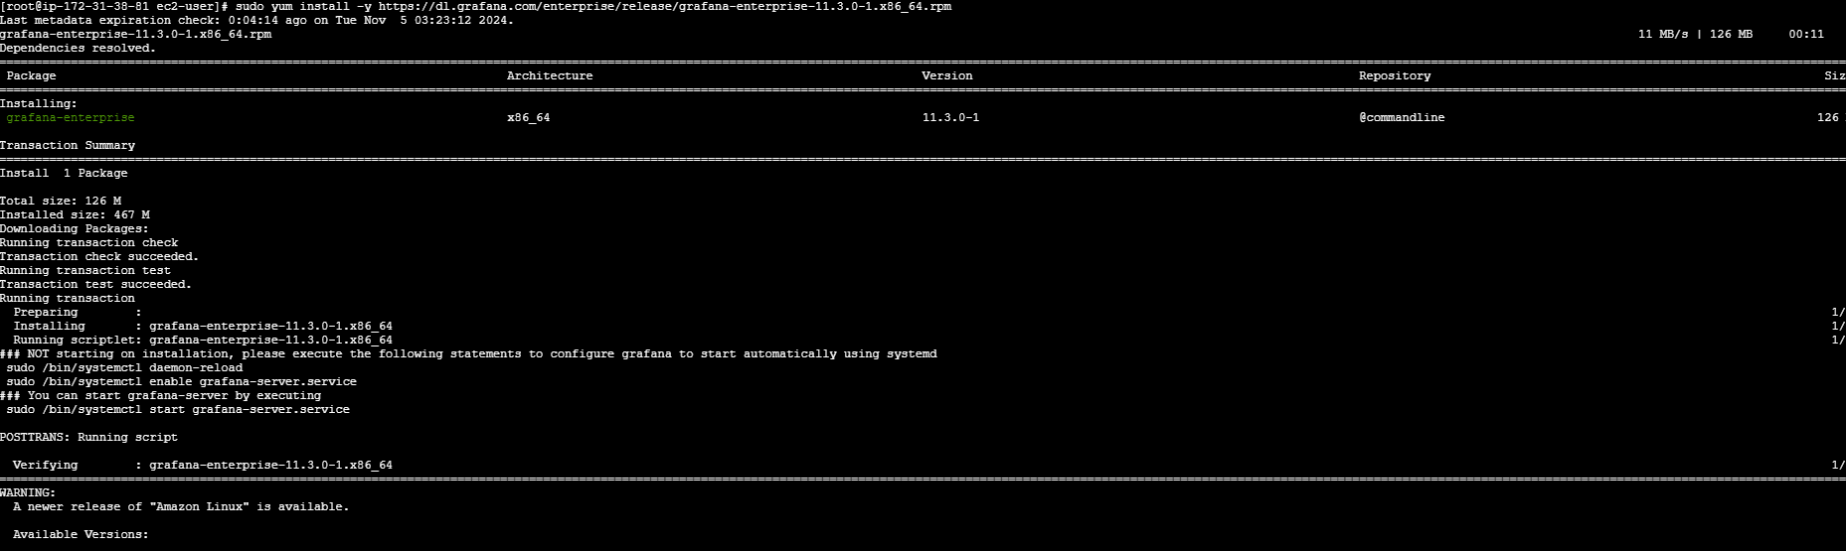

**sudo /bin/systemctl start grafana-server**

**systemctl status grafana-server**

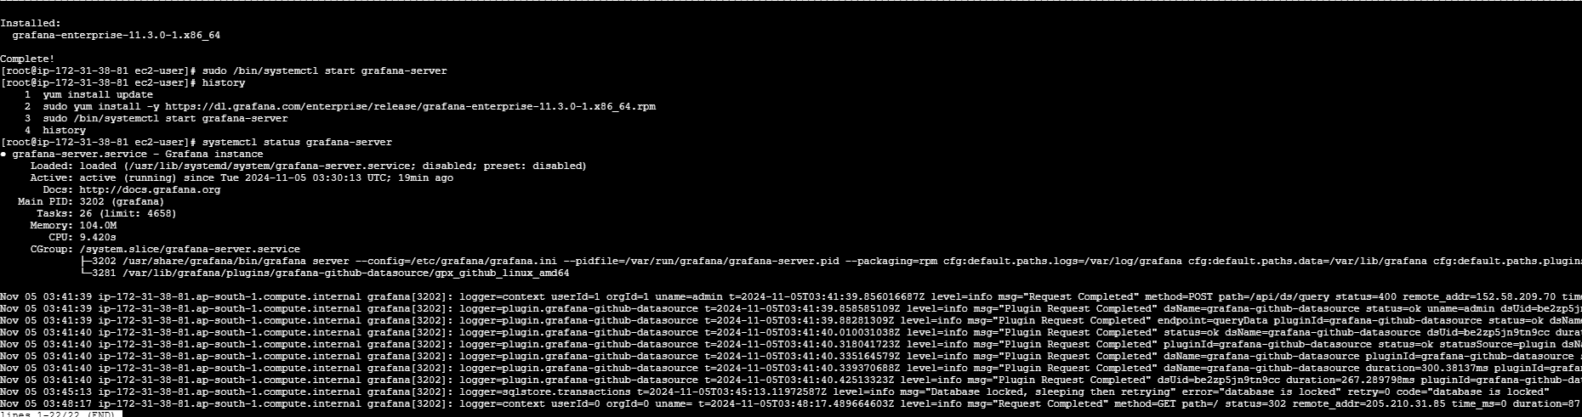

Now open the Grafana dashboard in web browser tab using <ip_address of system>:3000

Initially admin is the username and password. We need to re set the password.

Below is the Grafana Dashboard.

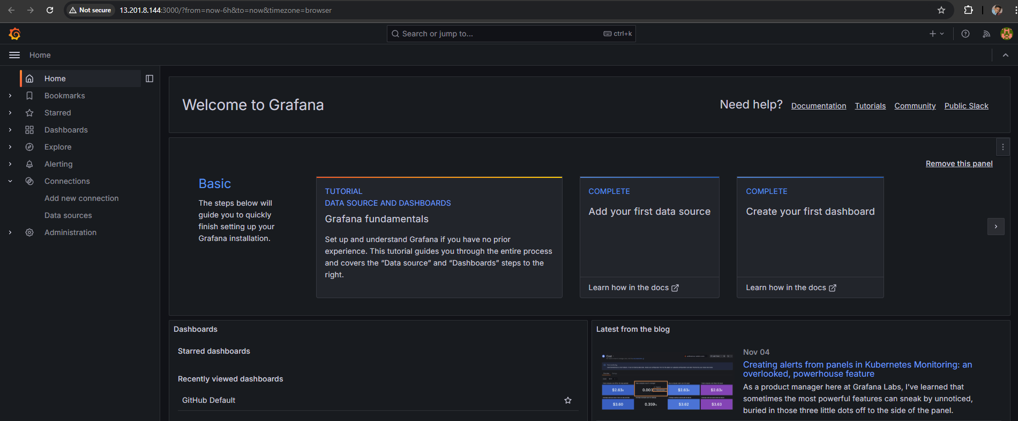

**Step 3: - Add or Install Github data source in Grafana**

Navigate to Connections in left pane then click on Data Sources.

By default github datad source is not installed we need to install the data source by clicking on “Find more data source plugins”.

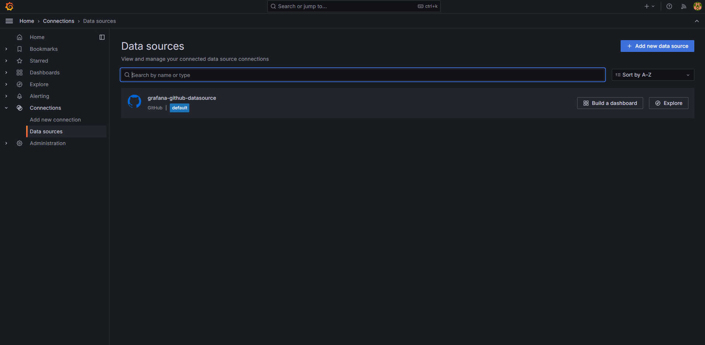

**Step 4: - Connect GitHub to Grafana using Personal Access Token**

Now create the Personal Access Token in Github with proper access which is required to Grafana.

(Not included the screenshot as it is confidential)

**Step 5: - Install or Import Github Dashboard Template using the Id available in the internet.**

We can create dashboards manually or we can use already created dashboard by importing the dashboard ID. I used id 14000.

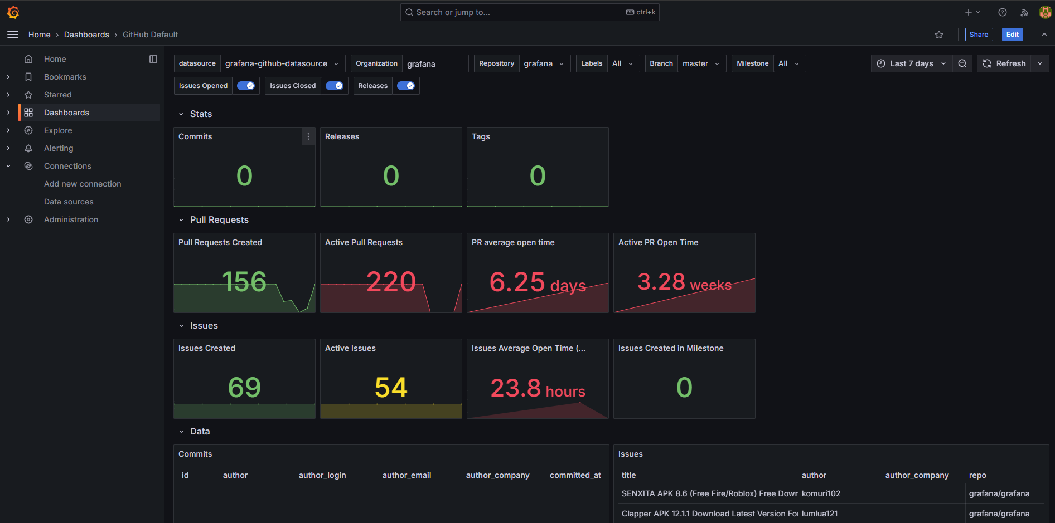

Add your account user name as organization and select the repository which we want to visualize .

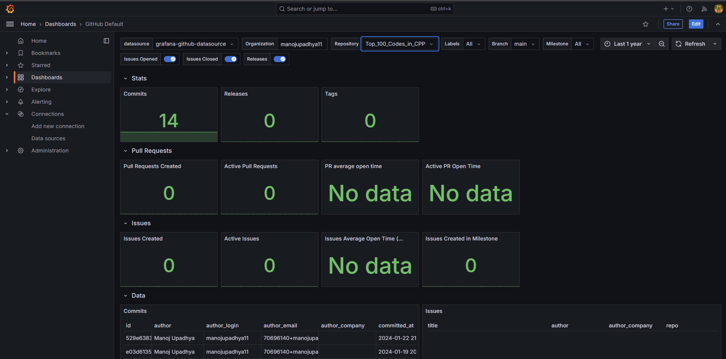  
  
Play along with different repository, we can change the time stamp also.